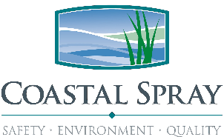
BEHAVIOR BASED SAFETY OBSERVATION FORM

Your concerns for safety and suggestions on how to improve our safety program are important. Use this form to submit either safety improvement input and/or a BBS Safety Observation. Your name is optional and the name of the person being observed is not to be used. This information will be used to continually improve our safety system and conditions.
BBS Observation |  |  | Unsafe Act |  |  |  | Unsafe Conditions |  |  |  | Recognition |  |  | Environmental
Employee/Observer Input:
Employee’s Action Taken or Recommendation:
Supervisor or Management Action Taken:
PPE/Procedures/Methods |  |  |  | Body Position/Mechanics |  |  |  | Slips / Trips |  |  |  | Environment /Work Environment
S | C | Eyes & Head |  | S | C | Proper Position |  | S | C | Proper footwear |  | S | C |  | SDS if needed
S | C | Hand & Body |  | S | C | Ask for Help |  | S | C | Aware of hazards |  | S | C |  | Lock out
S | C | Footwear |  | S | C | Use Dolly |  | S | C | Prompt clean up |  | S | C |  | Tools are safe
S | C | Trained on Task |  | S | C | Smaller Loads |  | S | C | Tripping hazards |  | S | C |  | Adjacent work
S | C | Work Permit/JSA |  | S | C | Don’t twist Body |  | S | C | Not rushing |  | S | C |  | Signage if needed
S | C | All trained in BBS |  | S | C | Get close to item |  | S | C | Step Conditions |  | S | C |  | Spill control
Observer’s feedback given to other employee:
Location: Observer Name: Date:
Promptly give this form to your supervisor who will review it and who must forward it to Coastal Spray Company Safety Manager for action.

